Servlet Practical

Name: Nur Aina Farisha binti Muhmad Jaffar

Matric No.: 196488

1. web.xml

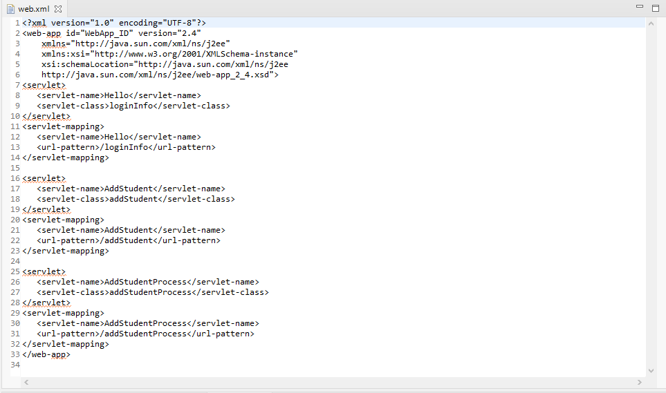

Pages produce based on classes created in the eclipse.

1. login.jsp

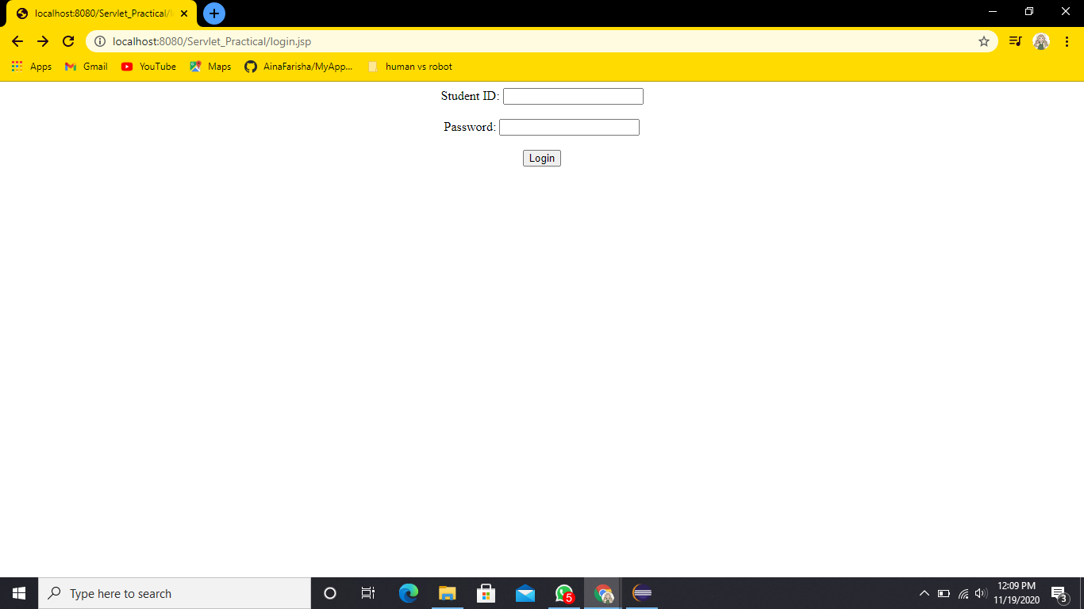

1. logininfo.java

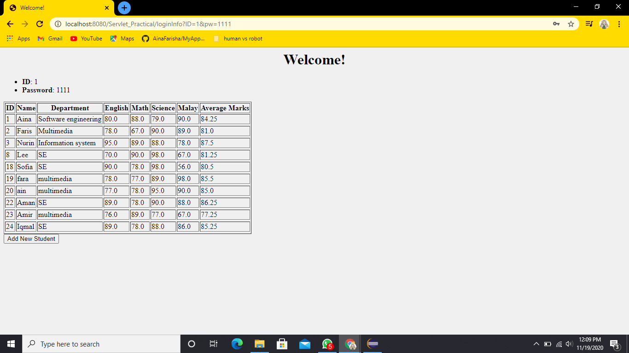

1. addStudent.java

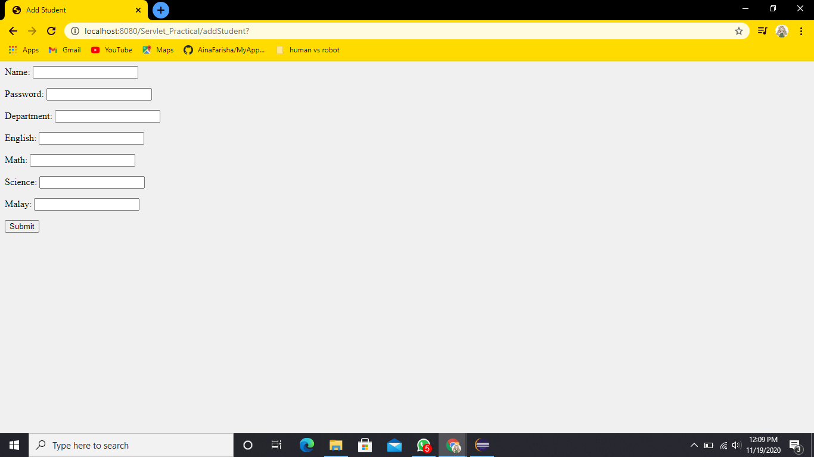

1. addStudentProcess.java

